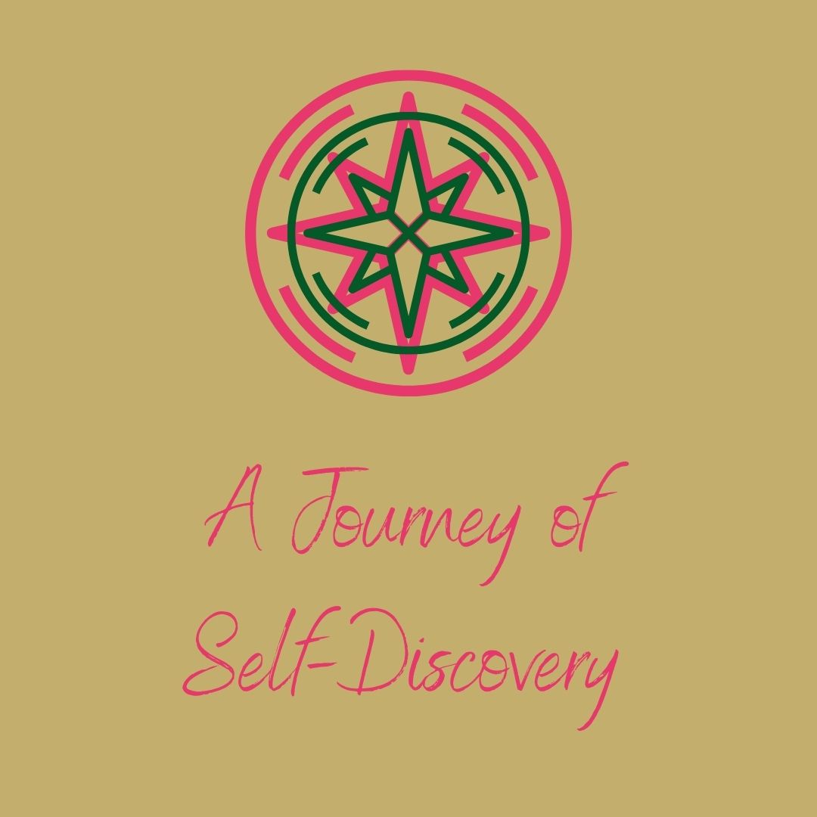

Welcome to your Self-Discovery Journal to help as you enjoy the teachings I share with you this month. Your journal is divided into 4 sections, to offer you the space to reflect at the end of each week. Take one section at a time.
Journaling is a powerful process that helps you to connect with how you are feeling and what you are thinking. Don’t judge what you write on the page, just allow it to flow from you. Making a ritual when you journal can be a nice way to slow the mind and body down. You could safely light a candle and put on some gentle music and put pen to paper.

Part 1: Discovering My Purpose
What do you feel your purpose is?

What joy does this bring you?

What challenges does this bring you?

What can you do to fulfill your purpose more?

How has your purpose shaped you?

Who are you?

What did you come to this life to do?

Are you doing that?

Part 2: Uncovering My Greatest Lessons
What difficulties in your past have strengthened you?

Why do you feel that these experiences gave you more strength and resilience?

What did you learn from these experiences?

Take time now to think and write about emotional/physical/mental healing you have experienced in your life after difficult past experiences?

How did this healing happen?

How did this healing help you evolve and grow in your life?

Part 3: Understanding My Personal Creativity
[Remember that creativity comes in many forms]

What wonderful things have you created in your life?

What activities/practices help you to connect within?

How often do you do these?

Finish this statement: I have a fire in my belly to do…

How can you tap into your creative energy more?

How can you use your creative energy more?

Week 4: My Path Ahead…
What do you truly wish for yourself in your life?

How do you truly wish to be?

What do you truly wish to do?

How can you begin to do all of these things whilst blending your purpose, your healing and your creativity?

