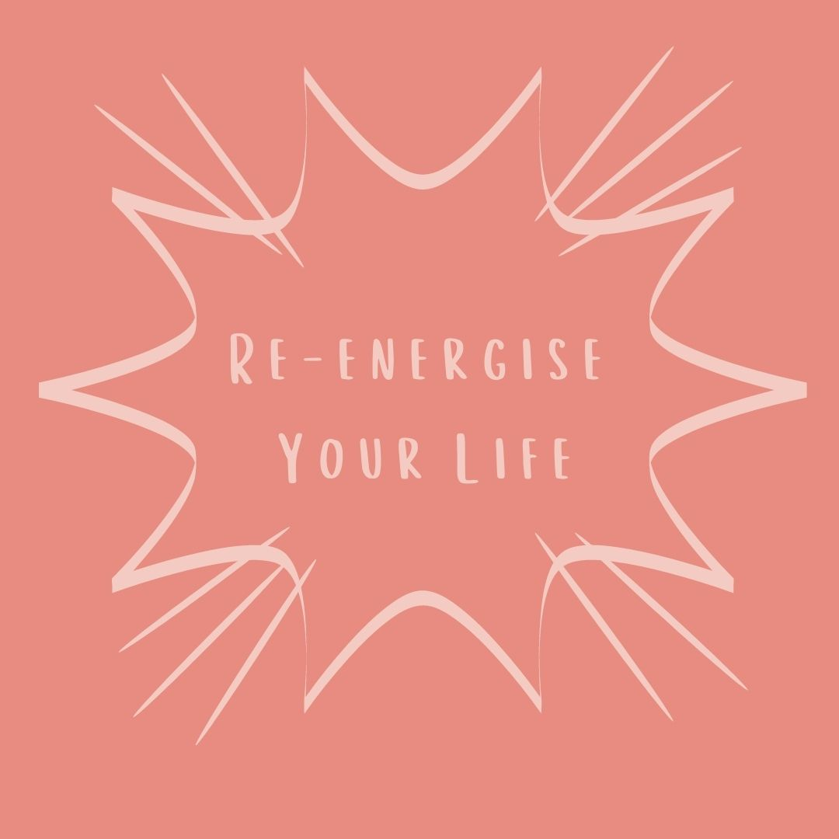
Well done on taking the time for yourself to journal and reflect. Writing is a powerful way to connect with your thoughts and emotions and offers you insight into the next steps that your highest self wants to take. This month is all about re-energising your life. Offer yourself the time and space for journaling this month by getting cosy in a quiet place, light a candle safely, play some gentle music and just let your thoughts flow onto the page.

Take time to look at the wheel of life below and out of 10; 0 being the lowest energy and 10 being the highest energy; grade the energy each part of your life has.
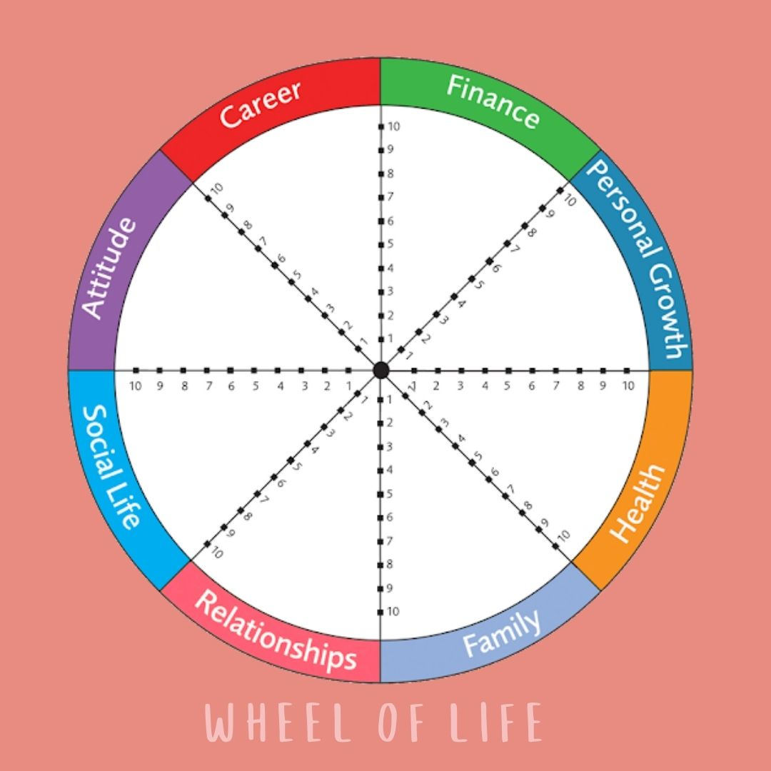

Write out why each area is low, medium or high in energy?
e.g. My career has low energy because I am unhappy, burnt out and do not like what I do.
e.g. My health has high energy because I am giving time for my wellbeing and I am fit and healthy.

In the areas that have low to medium energy write out why you would like these areas to improve?

What would you need to do or to change for these areas to improve?

What have you felt good about, has changed or you have achieved this year?

Why do you feel good? Why have things changed? Why did you achieve this?

What is your goal for the next 30 days?

Why have you set this and what are you going to do to achieve it?

What is your goal(s) for the next 4 months ahead?

Why have you set this and what are you going to do to achieve it?

How can you keep a light and bright energy in your life over the coming months?

What can you do to help your physical, mental and emotional self when you dip in energy or feel low?

Space for your own thoughts….

