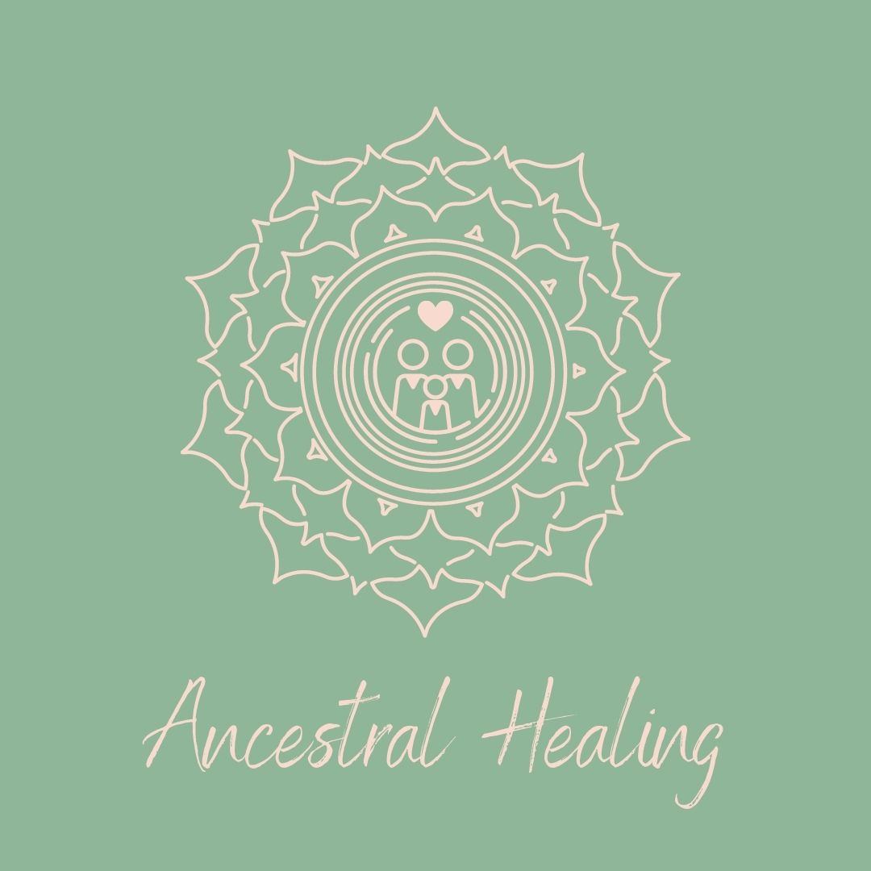

Welcome to your Soul Journal for this really special month. I am delighted that you are taking the time for your ancestral healing and I hope it brings more clarity, understanding and flow to your path in life.
The first part of this journal is to be used at our Soul Gathering on Sunday 15th August or during the replay. Please give yourself space and time to continue this further or add more as the weeks come up.
The second part of this journal can be used by you at anytime after our class over the coming weeks.

My wish for you is great healing and a life that feels aligned and wonderful to you. You deserve nothing but the best!

PART 1
(To be answered at the class/replay)

I would you like to heal my ancestral line because…

I have recognised that the following emotions, physical feelings, energy or circumstances do not feel like they were meant to be part of my life…

I feel I have carried down energies/circumstances from the following person/people in my family?

I can see similarities between my life story and the life story of this person…

FAMILY TREE
(Please use a pencil to draw this tree based on the instructions during class)

PART 2
(You can complete this part of your journal at any time after our class)

I would like to hand back all that doesn’t belong to me because…

I am grateful to all the generations that came before me because…

I feel now that I have handed back these things that I will be free to…

Now that I am aware of what does not belong to me, how will I maintain this awareness?

I believe I am meant to live a life that is…

