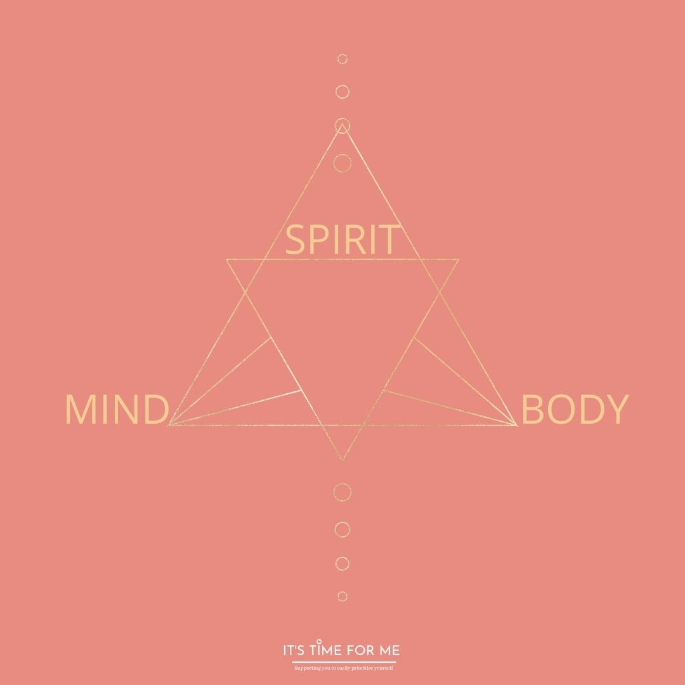
This month we will be using our Journal at our Monthly Soul Circle but you can take time also to do this after the class/replay class.

Your Body, Mind and Spirit can work in harmony with each other. What does this mean to you?

Do you feel your Body, Mind and Spirit are in flow with each other?
If yes, why? If no, why?

How often do you create space within the body for it to feel calm and balanced?

How often do you stop and listen to what your body needs and is asking you for?

Is your life in flow?

If yes…how does your body feel?
If no…how does your body feel?

Do you overthink?

Do you operate your life from your mind or your heart?

Do your thoughts hinder you or help you and why?

Is your mind creating space for you to thrive and flourish?

What do you believe your Soul is?

Do you listen to what your Soul wants for you?

My Soul is craving…

My Soul needs me to…

My Body, Mind and Spirit need what to work in harmony?

