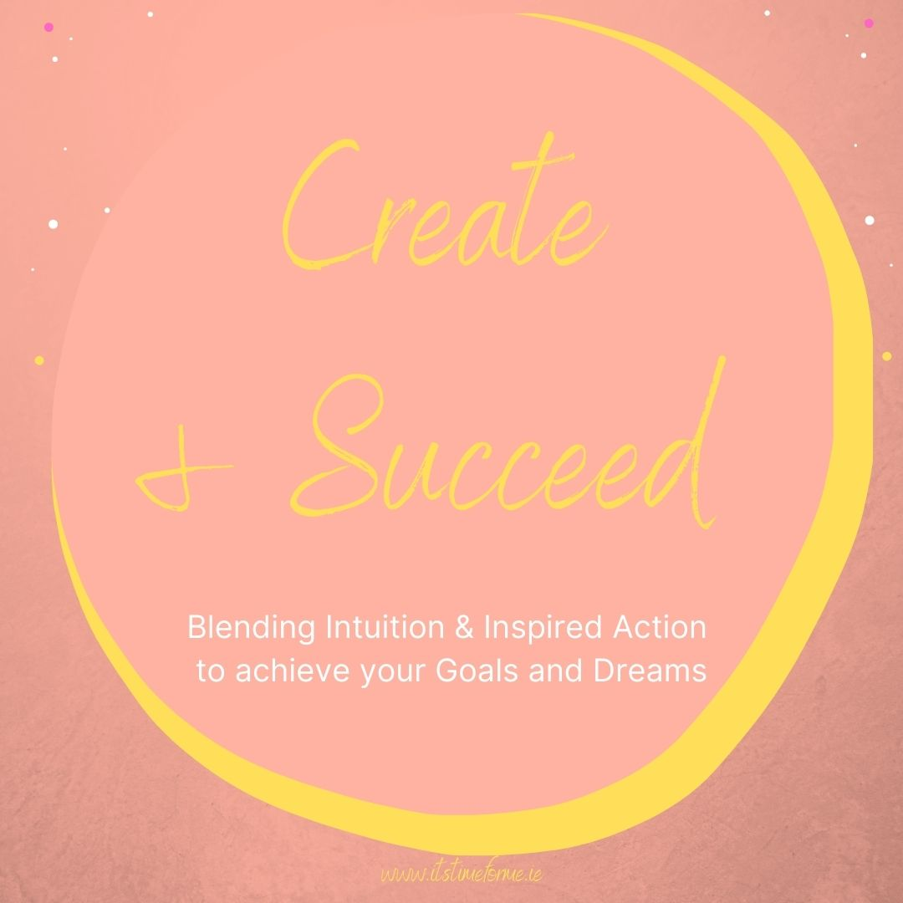

My wish for you is to have an uplifting and motivating month ahead, where you believe in yourself, where you know your worth and you are ready to go for your desires and dreams in a way that feels enjoyable and in alignment with what you know is the best for you.

Take time to create a comfortable and cosy space. You could safely light a candle and put on some relaxation music. Allow the pen to flow and don’t judge your thoughts or what you write.

I am ready to create and succeed because…

What holds you back from creating your goals and dreams?

What do you feel you need to help you work through this?

Take time now to write out all the wonderful things you have achieved in your life so far?

Now take time to write out the wonderful and capable parts of you that helped you to achieve these things.

Think of a time you wanted something but it didn’t happen or you “failed” while trying?

How did you feel?

What did you learn and how did you move on?

Write out all the reasons that you are going to approach your dreams and goals differently now?

Write out an affirmative statement about what you will do next.
e.g. “I am ready to achieve my dreams. I know I am capable and I know I can do this”

