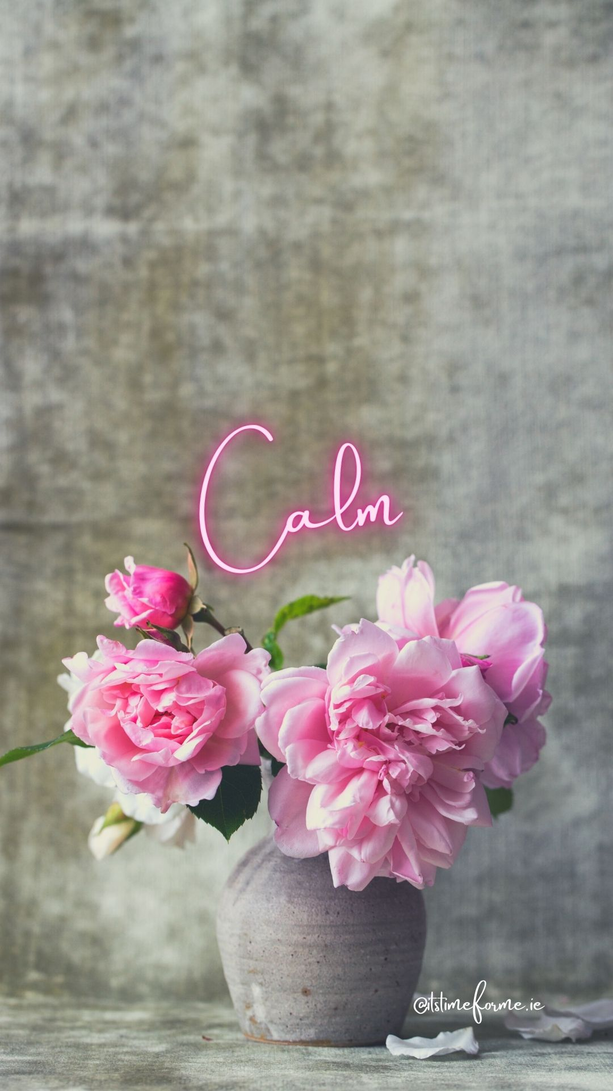
Wishing you a month ahead of calm and peace. Take time to do your journal.

Create a comfortable and quiet space for yourself and have as much time as you need.
Safely light a candle (do not leave it unattended).
Pour yourself warm water or a cup of herbal tea.
Put some relaxing music on.
Allow yourself to write at your own pace.
Enjoy.

Answer the following journal prompts. Allow the mind to just write whatever comes up. Don’t judge it….simply let your pen flow.

I notice I am calm when…..

I notice I am not calm when….

I would like to feel more calm because….

I feel I can create more calm in my life by….

Things that make me feel calm are…..

Things that don’t make me calm are….

To feel calm I need to clear the following from my life…..

I am ready to release the following to help me feel calmer…..

I am grateful for…...

Other things that come to my mind to help me on my path to calm are….

