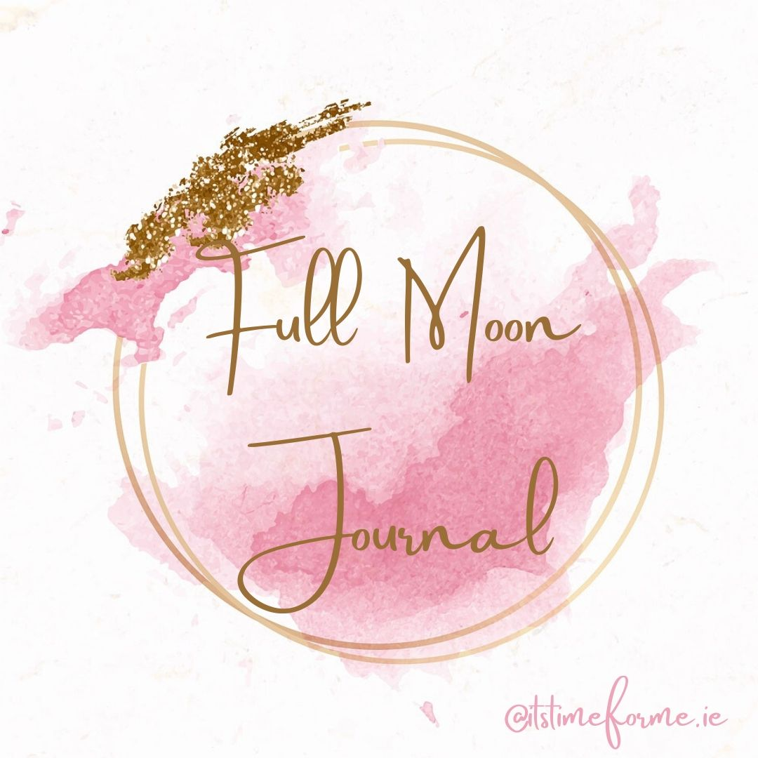

Take time for a moment to free write about what came up for you in our Releasing exercise…

Why are you ready to release these things?

What do you wish to create in the next 6 months?
Get imaginative and dream big!

