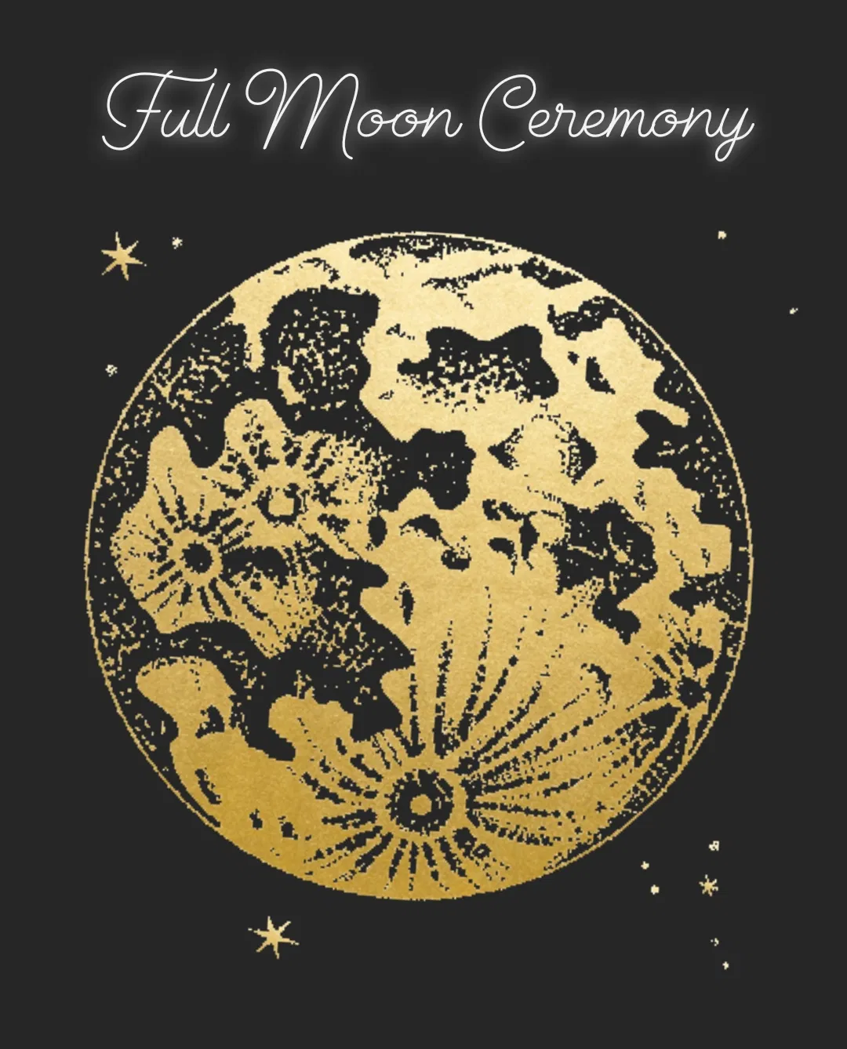

Release & Let Go

On this Full Moon, 9th March 2020, I am now ready to let go of……

The things that were causing me difficulty back in 2017 and still not have gone from life are………

I am now fully ready and willing to release all of these from my body, mind and soul.

I am ready for love, joy, happiness and abundance.

I am ready to elevate and thrive and I am truly ready to mind myself more.

