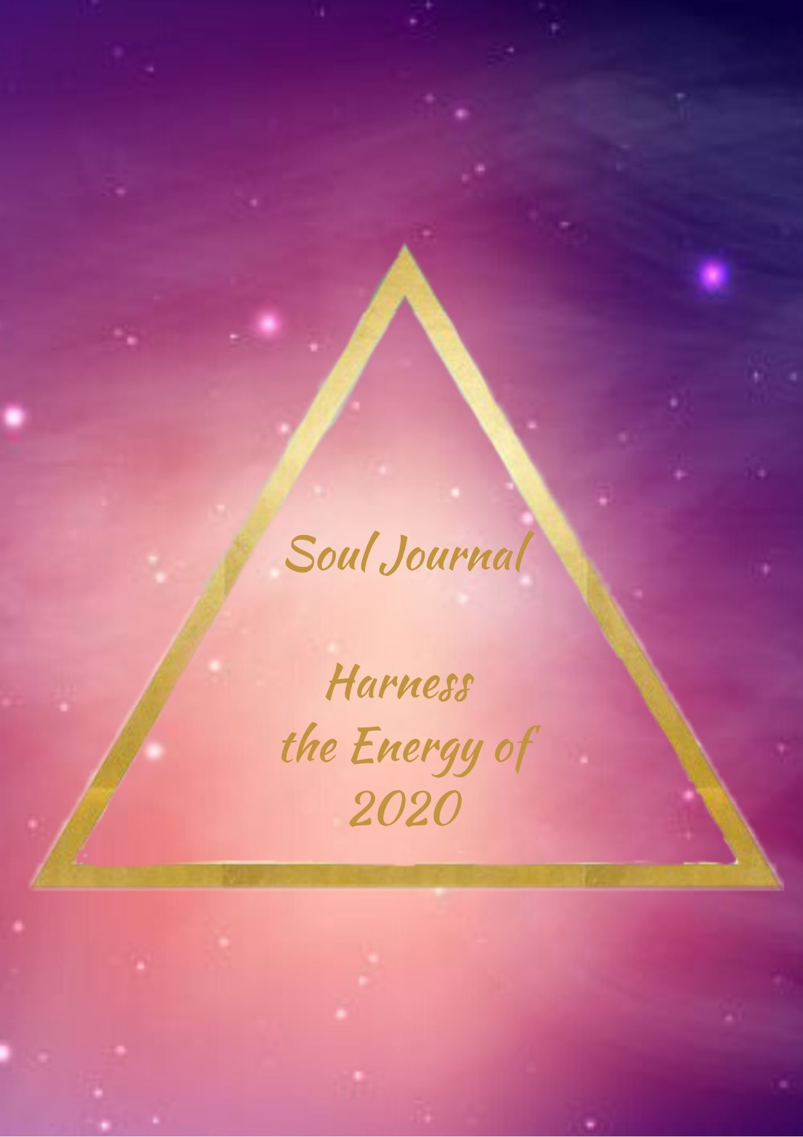
Harness the Energy of 2020

What are you ready to let go of from the past year?

What are you ready to let go of from the past decade?

What Soul Lessons did you learn over the past decade that you can use now to bring you forward in life?

What lessons keep repeating in your life that you are ready to understand more about?
(We will cover this in our Live Online Class on Thursday 23rd January)

Why do you think the lessons keep reoccurring for you?

What are your intentions for 2020?

What has been holding you back from fully living life as your true self?

How can you empower yourself this year?

What things do you want to focus on this month?
(Please feel free to email or text me with what these are, so I can include them in my teachings. Your information will be kept anonymous)

Well done on completing your Soul Workbook for January. You are clearing and cleansing this month to make way for great things!

