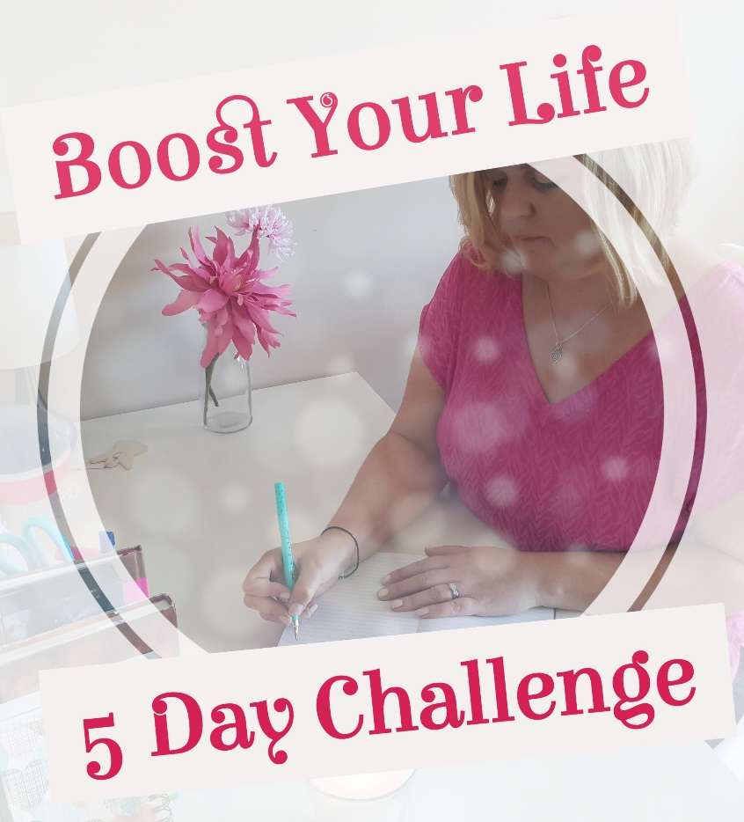

Welcome to Day 4 of the Boost Your Life - 5 Day Challenge. You are doing so well to have completed the previous days. I really hope you enjoyed getting creative yesterday and allowing yourself to think big

One of the most important aspects of change and tapping into the subconscious mind is to practice the Art of Allowing through Surrender and Trust. Today’s video focuses on these aspects and I give a personal story of how I have been experiencing this recently.

I look forward to connecting with you tomorrow as we reach the final day!

Caroline x

Surrender and Trust

To help with this process, it can be great to start with answering and focusing on the questions below.

What are you grateful for in your life right now? Start appreciating what you already have in your life.

What things happened previously or what lessons have you learned that were difficult at the time but in hindsight helped things to work out for the best?

This is one of my favourite things to do. Ask for a sign and pay attention.

Choose an animal, a flower, a symbol…something you might not see every day and when you are surrendering your wishes to the universe or something higher, you can ask to see that chosen thing to show you that you are on the right track.

Write below the thing that you choose and then when you see it come back and write about it.

Let Go…..
What one area of your life do you need to surrender and trust will work out?

Why do you want it to work out – what will it do for your life?

What practices will you put in place to surrender?
(e.g. Meditation, prayer, signs, stillness, focusing on the good you already have)

Copyright: Caroline Maria Meade 2018

