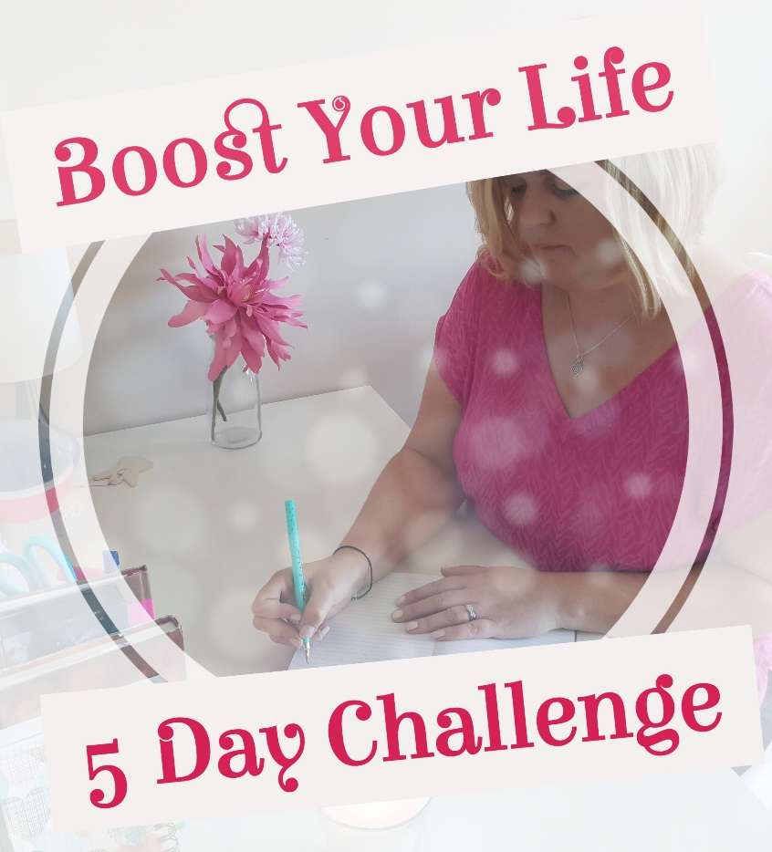

Welcome to Day 2 of the Boost Your Life - 5 Day Challenge. I hope you enjoyed Day 1 and took time to reflect on where you are in your life.

Today you will delve a little deeper into your subconscious mind. They say we begin creating our life through our mind and this is so true! What can be a roadblock, however, is that we don’t know what is going on in the ‘back of our mind’ and without knowing that we can repeat patterns, habits, keep having similar limiting thoughts and much more.

In the video you have watched, I have explained about how the subconscious mind can work and below you can begin to work on understanding your own subconscious mind and how to replace limiting thoughts with new ones.

Caroline x

My Subconscious Mind

- Think for a moment about your patterns and habits. What patterns and habits do you keep repeating?

- Take a moment now to go through each one you have written above and ask yourself ‘why do I do this?’ Sometimes it is hard to put yourself on the spot, so my suggestion when answering this question is just let the pen take over and begin writing. Don’t judge your thoughts and let the writing flow.

- Next, ask yourself when these habits or patterns began.

- Now as you are progressing and delving deeper…let’s go a little further. What, as far as you are aware, are your limiting thoughts and beliefs?

- Finally, what would you like to replace these limiting thoughts and beliefs with? e.g. I would like to replace my limiting thought a lovely of ‘I am not good enough’ with a new thought of ‘I am great’ / ‘I love myself’.

[I will be recording a visualisation to help you pull out the weeds of your subconscious mind and replace with new flowers which are positive, beautiful and progressive. That will help with this process also].

Copyright: Caroline Maria Meade 2018

