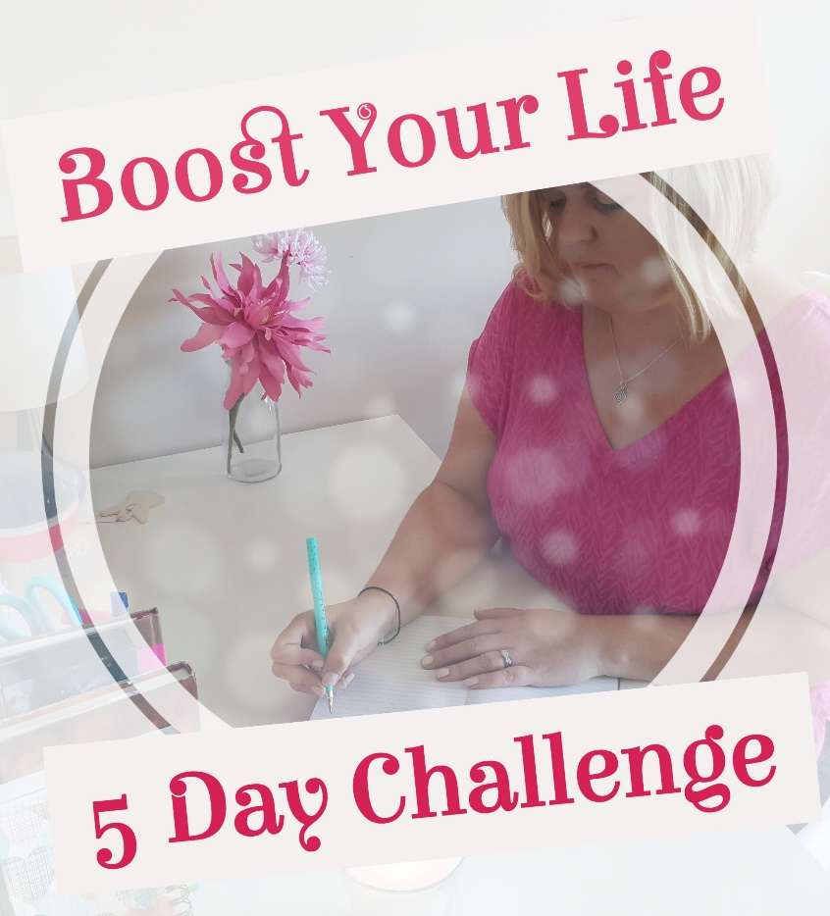

Welcome to Day 1 of the Boost Your Life - 5 Day Challenge. I am excited that you have decided to sign up and I look forward to bringing you lots of great help over the course of the next few days.

To get started, watch today’s video and then use this workbook to help you figure out your starting point. It doesn’t matter where you are in life you have the ability to progress and make change. Sometimes we just need a little help or support to get started.

Be gentle with yourself through this process. Don’t beat yourself up or feel bad about regrets you have, this is all about moving forward with positive focus. I hope you enjoy and I look forward to connecting with you tomorrow.

Caroline x

Where am I?

As you are beginning on a 5 day journey to boost your life it is very important to get an idea of where you are now in your life. Answer the questions below to help you.

- How are you feeling right now?

I feel…..

- How are you thinking right now? Is it positive or negative, or even somewhere in between?

I am thinking…..

- What limiting beliefs do you have?

The limiting beliefs I have are…..

- These beliefs hold me back because…..

Let’s get focused now on where you would like to go as you progress.

On ____ day of ___________ 201_ I would like to have achieved the following:

The biggest things holding me back from achieving my goals/dreams or getting to where I want to be are……

Well done…you’ve taken some great steps towards boosting your life!

Copyright: Caroline Maria Meade 2018

