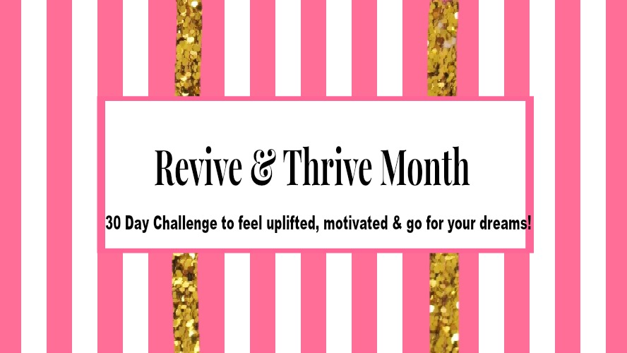

It is so easy to be feeling like you are heading in the right direction & achieving your goals and the next minute to feel completely lost, de-motivated and unsure what steps to take next.
I feel like this quite often and the highs and lows can be quite disillusioning. I started last month feeling excited and I worked hard on my goals but towards the last week and a half, I started to lose momentum.
I wanted to create this challenge to feel revived again, feel connected to myself, grounded, motivated and have full belief I can achieve all I set out to accomplish and my aim for this challenge is to help you do the same.

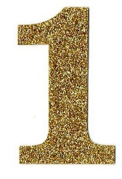
Now IS the Time!
How often have you promised yourself that this will be the day, week, month or year that you will get started on doing what is right for you and aiming for your goals….! What has stopped you?
Let’s forget about what has not happened and let’s focus on what CAN happen from today!
Are you ready? The first step is the hardest but the best!

“A year from now you will wish you started today”

You Deserve the Best!
To create a better life for yourself, you have to be ready to choose, commit and take part in that creation process. Every action and decision begins with a choice….a choice to live the best life you can, to acknowledge your difficulties & stresses but have faith in yourself that no matter how many of those difficulties & stresses are occurring that you are making the commitment to Revive & Thrive!
You are here for a purpose, you are here to live your dreams and let’s do all we can to accomplish that!

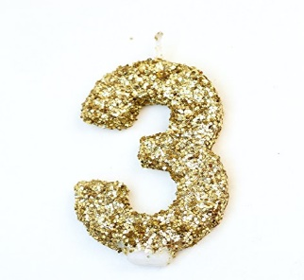
Enjoy Yourself!
The most important thing in this process, is that you do what you enjoy. If this feels like another “to-do” list or another chore, you just won’t do it.
Below is a checklist and planner to help you on your journey this month. Only put things on this that you will actually enjoy and it will feel a lot better and more achievable.

Let’s Get Started!
So, let’s look at where you would like to be by the end of this month.

What goals would you like to have achieved in the next 30 Days? Write them out below.
________________________________________________________________________________________________________________________________________________________________________________________________________________________________________________________________________________________________________________________________________________________________________________________________________________________________________________________________________________________________________________________________________________________________________________________________________________________________________________________________________________________________________________________________________________________________________________________________________________________________________________________________________________________________________________________________________________________________________________________________________________________________________________

By achieving these goals by the end of the 30 Days, what positive difference will it make to your life and how you feel emotionally?
________________________________________________________________________________________________________________________________________________________________________________________________________________________________________________________________________________________________________________________________________________________________________________________________________
Enjoy the 30 Day Checklist to help you achieve your goals.

